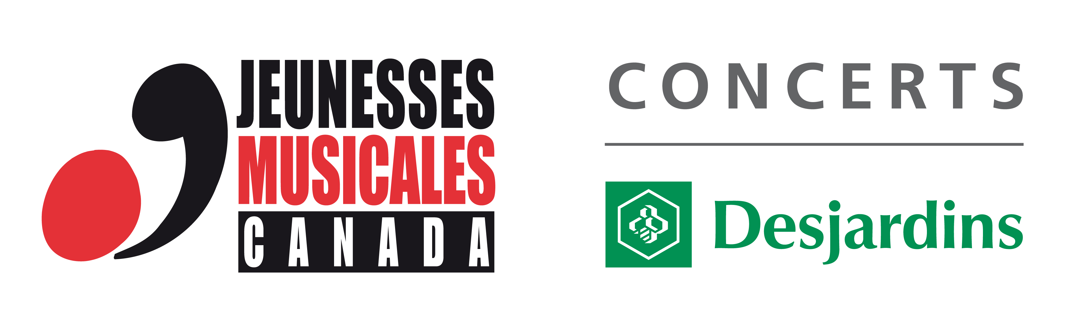
Press Release
For immediate release

Jeunesses Musicales of……………………………….presents
Roméo et Juliette by Charles Gounod

Date : ……………………….. Time : …………………………

Place : ……………………………………………………………..

Price : …………………………

As part of the 2015-2016 tour of the Concerts Relève presented by Desjardins, Jeunesses Musicales Canada (JMC) is proud to present Romeo and Juliet, the famous opera by Charles Gounod. This tour will bring the next generation of Canadian singers to several cities in Quebec, Ontario and the Maritimes.

About Romeo and Juliet...

Rediscover this epic story of two star crossed lovers swept along by a fate they cannot escape. Forced to defy the enmity of their families, they defend their love to the death. Director Oriol Tomas transposes Shakespeare’s famous work to present day in order to highlight the universality of its themes. Charles Gounod’s poignant score will be interpreted by the next generation of Canadian singers.

Concerts Relève

JMC is the only organization to offer a tour through its network of centers and volunteers. The artists, recruited at auditions across Canada, are given the opportunity to present a recital in different places and in front of diverse audiences. Over the years, JMC has supported over 2,000 artists, including Joseph Rouleau, Maureen Forester, Louis Quilico, the Orford Quartet, James Ehnes, Marie-Nicole Lemieux, André Laplante, Ian Parker and Stéphane Tétreault, all of them being internationally recognized artists and associated with the artistic elite of our country.

Desjardins

Desjardins is the largest cooperative financial group in Canada. Their mission: to contribute to the economic and social well-being of individuals and communities. They present the Concert Relève tour with JMC for the 14th consecutive year.

Distribution :

Juliette Capulet (Soprano colorature), Myriam Leblanc
Gertrude et Stephano (Mezzo soprano), Katrina Westin
Roméo Montaigu (Tenor), Tonatiuh Abrego and Marcel d'Entremont
Tybalt (Tenor), Marcel d'Entremont et Tonatiuh Abrego
Mercutio (Baryton), Geoffroy Salvas
Comte Capulet- Frère Laurent (Bass), Dylan Wright

Creation:

Oriol Tomas, Stage direction
Louise-Andrée Baril, Musical direction
Laurence Mongeau, Set and costume design
Charlotte Hoffmann, Technical direction
Julie Perron, Choregraphy
Julie Basse, Lighting design
Audrey Blouin, Stage assistant

Tour Team:

Audrey Blouin, Stage management
Pauline Schwab, Technical direction/lighting
Jean Sabourin, Tour management

Source:
Frédéric Barre
Communications Manager
t. 514 845-4108, ext 222
fbarre@jmcanada.ca
www.jmcanada.ca

